Excel Assignment – 6

1. What are the various elements of the Excel interface? Describe how they're used.

Ans: -

1. Quick Access Toolbar
2. File Tab
3. Title Bar
4. Control Buttons
5. Menu Bar
6. Ribbon/Toolbar
7. Dialog Box Launcher
8. Write down the various applications of Excel in the industry.

Ans: -

1. Data Entry
2. Data Management
3. Accounting
4. Financial Analysis
5. Data Analysis
6. On the ribbon, make a new tab. Add some different groups, insert commands in the groups and name them according to their commands added. Copy and paste the screenshot of the steps you followed.

Ans: -

Step 1- Click on File option

Step 2 – Click on Options

Step 3. – Click On Customize Ribbons

Step 4. – Click on New Group to add commands

Step 5. – Click on the Save Options.

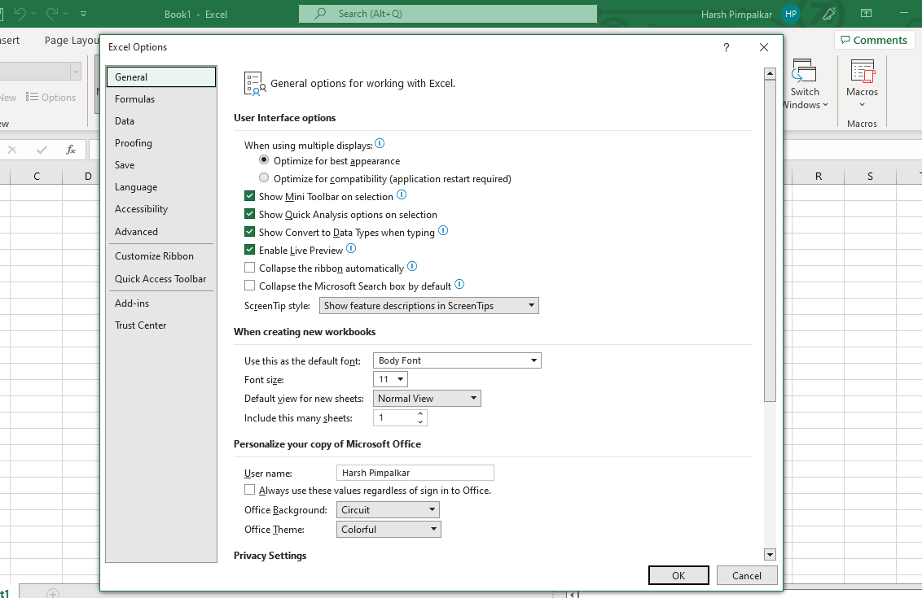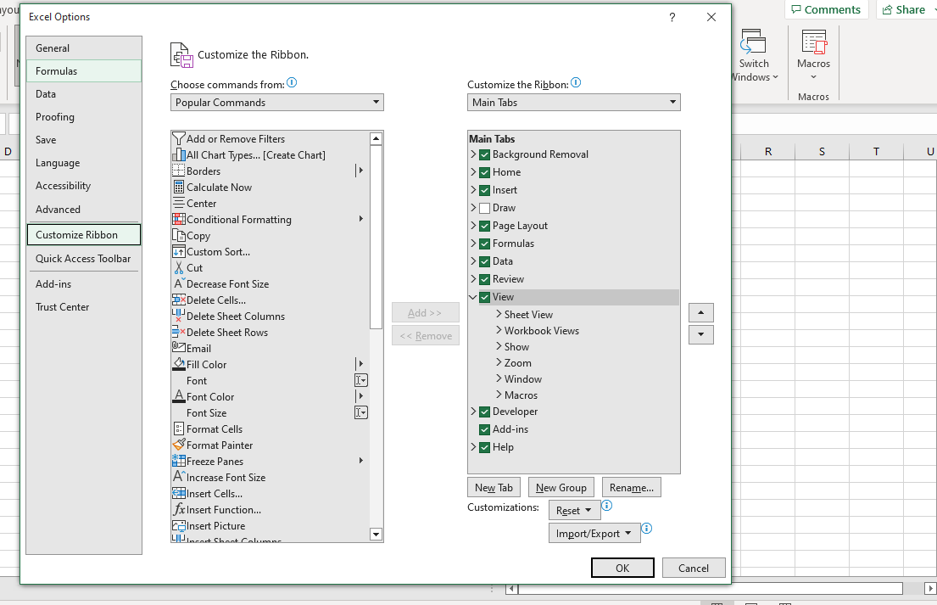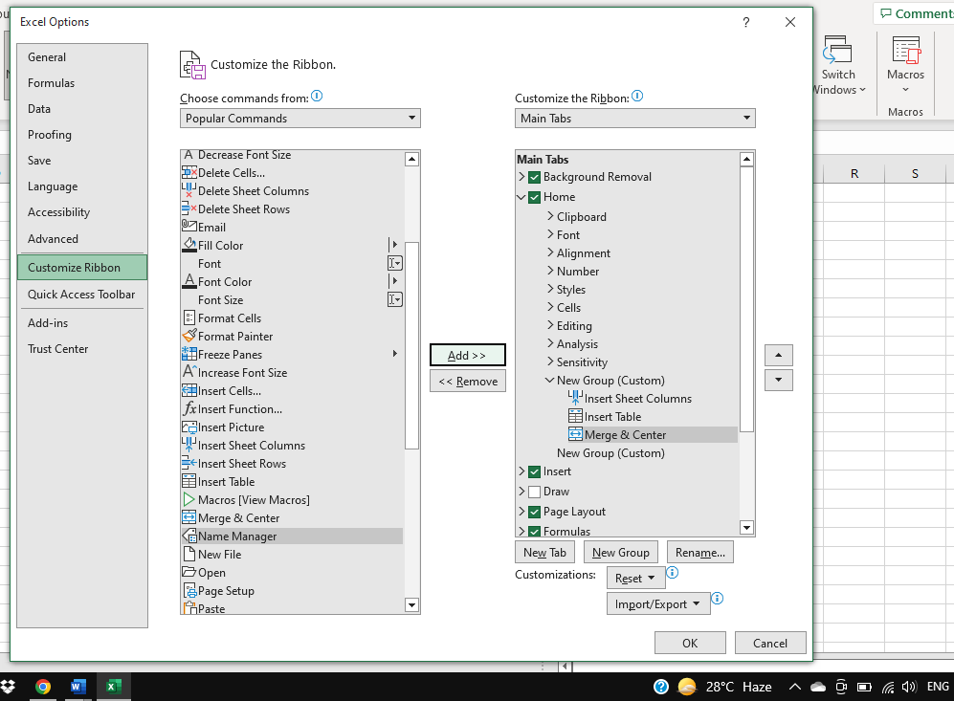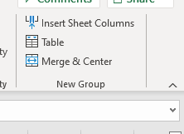

1. Make a list of different shortcut keys that are only connected to formatting with their functions.

Ans :-

|  |  |  |  |  |  |  |  |  |  |  |  |  |  |  |  |  |  |  |  |  |  |  |  |  |  |  |
| --- | --- | --- | --- | --- | --- | --- | --- | --- | --- | --- | --- | --- | --- | --- | --- | --- | --- | --- | --- | --- | --- | --- | --- | --- | --- | --- |
| |  | | --- | | 1. Edit a cell-F2 | | 1. Copy and paste cells-Ctrl + C, Ctrl + V | | 1. Bold and italicize the fon-Ctrl B, Ctrl I | | 1. Underline to the cell content-Ctrl + U | | 1. Center align cell contents-Alt+H+A+ C | | 1. To fill colour- Alt + H + H | | 1. Add a border-Alt + H + B | | 1. Remove outline border-Ctrl + Shift + _ | | 1. Add outline to the select cells-Ctrl + Shift + & | | 1. Move to the previous cell-Shift + Tab | | 1. Move to the next cell-Tab | | 1. Select cells on the right- Ctrl + Shift + Right arrow | | 1. Select cells on the left-Ctrl + Shift + Left Arrow | | 1. Select the column from the selected cell to the end of the table-Ctrl + Shift + Down Arrow | | 1. Select the data above the selected cell- Ctrl + Shift + Up Arrow | |  | | 1. Add a comment to a cell-Shift + F2 | | 1. Display find and replace- Ctrl + H | | 1. Activate Filter-Alt + Down Arrow | | 1. Insert the current date-Ctrl + ; | | 1. Insert current time-Ctrl + Shit + : | | 1. Insert a Hyperlink-Ctrl + k | | 1. What distinguishes Excel from other analytical tools?   Ans: -   1. It’s easy to get started with excel 2. The learning resources are very rich. 3. You can do a lot of things with excel:- Modelling, reports, dynamic charts, etc. | | 1. Create a table and add a custom header and footer to your table.   Ans : | |  | |  |
|  |  |
|  |  |
|  |  |
|  |  |
|  |  |
|  |  |
|  |  |
|  |  |
|  |  |
|  |  |
|  |  |
|  |  |
|  |  |
|  |  |